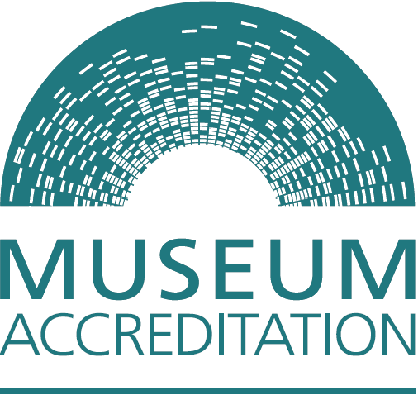

Accreditation Scheme for Museums and Galleries in the United Kingdom

Eligibility Questionnaire

The Accreditation Scheme is managed as a partnership between Arts Council England, the Welsh Government, Museums Galleries Scotland and the Northern Ireland Museums Council.

We’ll use the information you provide in this form to check whether your museum is eligible to apply for Accreditation. You’ll also need to send us a copy of your governing document and confirmation of your commitment to making an Accreditation application within three years.

For guidance and prompts on filling in this questionnaire, and details of who to contact for advice, please read the Accreditation Eligibility and How to Apply guidance.

Main contact:

Title:
First Name:

Last name:

Job title/position:

Correspondence address:
Postcode:

Telephone number:

Email address:
Please indicate whether these details are personal or business:
Personal ☐ | Business ☐
For reasons of speed and cost we prefer contact by email. If you would prefer contact by post – please tick here ☐

- Is the museum based in the UK, Isle of Man or Channel Islands? Yes ☐ / No ☐

Name of museum:
This is the name you use to market the museum.

Museum address including postcode:

- Does it meet the agreed definition of a museum? Yes ☐ / No ☐

The Museums Association definition of a museum (1998) is:
“Museums enable people to explore collections for inspiration, learning and enjoyment. They are institutions that collect, safeguard and make accessible artefacts and specimens, which they hold in trust for society”

Please describe briefly how your organisation meets this definition (max 300 words):

- Is the museum a physical site/space/building which is open to the public regularly? Yes ☐ / No ☐

Briefly describe the museum’s opening arrangements (max 300 words):

- How are the public able to experience and engage with the museum’s collections?

Please outline how this takes place (max 300 words):

- The museum must have an appropriate constitution

A constitution is a legal document which sets out an organisation’s aims and how it is administered. You’ll need to send us a copy of the latest approved version of your constitution.

Name of governing body:

What type of constitution does your organisation have?

Act of Parliament ☐
Royal Charter ☐
Local Authority ☐
University ☐
Charitable Trust ☐
Charitable Company ☐
Charitable Incorporated Organisation & Scottish Charitable Incorporated Organisation ☐
Community Interest Company ☐
Community Benefit Society (also known as BenCom) ☐
Unincorporated Association ☐
Other ☐

If you selected Other, please expand here:

Please outline which regulatory framework your museum operates under.
For example, is the museum registered with the Charity Commission/ Office of the Scottish Charity Regulator or another regulator? (max 300 words):

Your charity number:
Your company number (if relevant):

The constitutional entity must legally mean that the museum:

- Exists for public benefit
- Can demonstrate its collections and assets are appropriately protected
- Has powers to operate a museum and hold collections and assets, these powers must be transparent and should not include the ability to distribute assets or profit for private gain
- Is subject to statutory regulation or judicial process in relation to its conduct
- Must be a permanent entity with a long-term purpose

Please attach your museum’s current constitution / governing documents. Briefly describe how they meet each of the constitutional criteria 1-5 above (max 500 words):

Please confirm whether the governing body operates the museum directly or has contracted a separately constituted management organisation:

Directly managed ☐
Contracted ☐

- Where a hybrid management model exists, you’ll need to provide copies of any agreements between the governing body and the managing organisation. This might include documents such as a management or service level agreement, or a collections loan agreement.

- In cases where running a museum is not the main purpose of an organisation, e.g. a police authority or a university / higher education establishment, we’ll require additional information. If the governing body has set up a managing committee to manage the museum please provide any agreed terms of reference, and information about the line of authority and approvals link from the governing body to museum activities.

- Commitment and timescales for making an application for Accreditation

Please evidence your commitment to making an application for Accreditation within a three-year period. Include an outline of your planned timescale (max 300 words) and provide supporting evidence via a cross-referenced attached document, e.g. Forward/business plan, letter from trustees etc.

The completed form is to be signed by a member of the governing
body or by an individual, authorised to sign on behalf of the governing body. Please note that we can accept a typed signature, or a photograph/scan of a signed hard copy.

Signed:

Name:

Position:

Date:

Data Protection
Any personal information you provide will be used purely for the purpose of determining whether the museum you represent can apply for Accreditation. No personal information provided will be published unless as otherwise required by law and all data will be handled in accordance with the General Data Protection Regulation and the Data Protection Act 2018. For more information contact accreditation@artscouncil.org.uk

Submitting your Eligibility Questionnaire for review
Please submit your Eligibility Questionnaire along with the latest approved version of your constitution. You will also need to attach evidence of your commitment to making an Accreditation application within three years.

Please email the documents to your relevant UK Partner assessing organisation:

Northern Ireland
Northern Ireland Museums Council
Email: devofficer@nimc.co.uk

Scotland
Museums Galleries Scotland
Email: accreditation@museumsgalleriesscotland.org.uk

Wales
The Welsh Government
Email: MuseumDevelopment@gov.wales

England, the Isle of Man and Channel Islands
Arts Council England
Email: accreditation@artscouncil.org.uk

Museums based in England – for Accreditation advice and support please contact your local Museum Development team. For further details please see the Accreditation: Eligibility and How to Apply guidance in the Accreditation Guidance Library.

