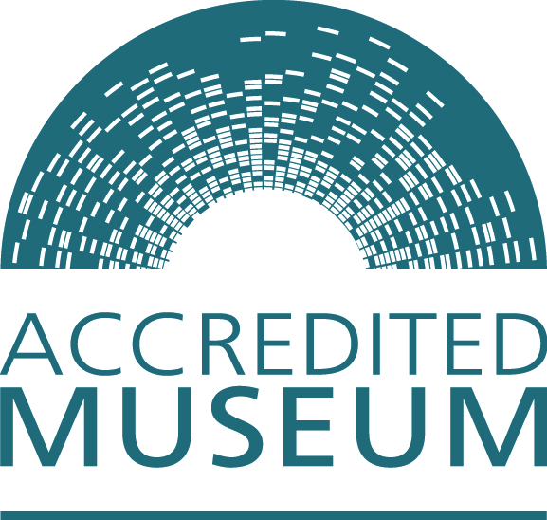

Accreditation Scheme for Museums and Galleries in the United Kingdom:
Museum mentor handbook
Section four - templates

November 2011

Contents

Museum mentor log | 3
Accreditation skills assessment tool | 4
Sample museum mentoring agreement | 6
Accreditation review: | 9
Museum Accreditation review form A | 10
Museum Accreditation review form B | 13

Museum mentor log

Museum:

Date | Hours/ time | Advice given/ engagement activity | Resulting museum action

Accreditation skills assessment tool

Use this form to review your skills when you begin as a mentor and then every three years. This tool will help identify your strengths and skills, and assist in identifying where others can help. It will assist in developing your offer as a mentor to the museum - be honest with yourself about your abilities and seek support from other colleagues, advisers or networks when necessary.

Requirement | Can you advise Y/N | Need additional skills/knowledge - describe | Skills/ knowledge source
1.1 Clear statement of purpose
1.2 Acceptable constitution
1.3 Management arrangements
1.4 Effective forward planning
1.5 Secure occupancy
1.6 Financial basis
1.7 Appropriate workforce
1.8 Professional advice
1.9 Emergency plan
1.10 Environmental sustainability

2.1 Satisfactory arrangements for the ownership of collections
2.2 Development policy
2.3 Documentation policy
2.4 Care and conservation policy
2.5 Documentation plan
2.6 Care and conservation plan
2.7 Documentation procedures
2.8 Security arrangements

3.1 Good-quality services and development
3.2 User-focused experience
3.3 Effective learning experiences

Sample museum mentoring agreement

This agreement is between the governing body of the [insert museum name] [insert accredited number] and [insert name of museum mentor].

Name of museum contact person: | Name of mentor:
Museum address: | Mentor address:
Museum telephone number: | Mentor telephone number:
Email address: | Email address:

Museum
Overview of collection:

The main services the museum provides are:

Museum mentor
My background and experience is:

My key skills are:

Accreditation status of the museum

Date museum entered Accreditation:

Current status:
(Full, Provisional, working towards)

The museum mentor will:

- Advise the museum on obtaining Accreditation and from then on support the museum in maintaining the standards. In order to provide a framework for this activity the mentor will:

  - Work on an annual Accreditation review with the museum, looking at the forward plan and discussing the museum’s advice needs for the coming years
  - Help the museum source that advice
  - Endorse and sign Accreditation applications and returns
  - Visit the museum a minimum of twice a year of which one visit must be a governing body meeting

In order to support the museum he / she will:

  - Make contact details available and communicate with the museum.
  - Be available or let the museum know if their availability changes
  - Keep up to date with current professional standards or know how to access further advice and information
  - Be an advocate for the museum
  - Support the museum in accessing networks and engaging with the wider museum community
  - Not advise outside his/ her areas of expertise but direct the museum to other sources of advice.

Additional points:

The Museum will:
- Work within the Accreditation Standard
- Work on an Accreditation review with the mentor, looking at the forward plan and discussing the museum’s advice needs for the coming years
- Consult the mentor regularly and use their expertise
- Invite the mentor to Trustee meetings with due notice and allow him/her to report
- Advise the mentor of any change in circumstances relating to Accreditation.
- Allow the mentor access to all areas of the museums work
- Keep the mentor informed through
  - Trustee minutes
  - Other relevant committee minutes
  - General mailings and information

Additional points:

Both the museum and the mentor will strive to develop a positive on-going working relationship

Signed:

Chair of governing body

Print name:

Signed:

Museum mentor

Print name:

Date

A minute accepting this agreement must be sent to:

Copies of this agreement will be sent to:
Accreditation review

The mentor and museum representatives should annually review the development of the museum against the Accreditation Standard. Take this opportunity to review the forward plan and assess the advice that the museum may need over the coming year in order to fulfil it. Include other key professionals such as the local museum support officer/team or Accreditation Advisor. If they are unable to be present, send them a copy of the information you create as it will help with the planning of regional training.

How to use this tool

- Review the forward plan with the museum. Be positive about all that has been achieved and realistic about what hasn’t. Encourage the museum to re-plan these areas. Don’t forget to include and required actions or areas for improvement from Accreditation in the process.

- On each area check what the progress has been and if the museum needs any assistance to complete this area. If the museum does need advice, agree with the museum what it is and where it will be sourced. Advice may come from you, the local advisory officer, other professionals you know, networks, websites, CPD, consultants etc. Museums should make the Advisor aware when the museum is most likely to need help and the Advisor warn the museum of restrictions on his/ her availability due to work pressures etc.

- Following the meeting write up what you have agreed and send it to the museum.

Take a common sense approach as all museums are at different levels and some need more support than others. The idea of this exercise is to enable progress and keep Accreditation Standards as a living process in the museum whilst helping the Mentor to support to an appropriate level. This level will be different for each museum and it is up to you pitch this appropriately, for instance if a museum is struggling you can use this process as a tool to sort things out. For another museum this may purely be a health check. Try to avoid creating extra paper work for the museum

Use form A – for your own use to plot where the museum is in the Accreditation process. In some circumstances you may wish to share it with the museum. You can then use this completed document to develop and complete Form B.

Use form B – to confirm your support and where advice is coming from for the following year.
Museum Accreditation review form A

Museum

Time period

Requirement | Development as outlined in forward plan with date for completion | Advice required | Advice source
Section one - organisational Health
1.1 Statement of purpose
1.2 Acceptable constitution
1.3 Management arrangements
1.4 Effective forward planning
1.5 Secure occupancy
1.6 Demonstration of financial basis
1.7 Appropriate workforce
1.8 Access to professional advice
1.9 Clear, workable emergency plan
1.10 Environmental sustainability

Section two - collections
2.1 Satisfactory arrangements for the ownership of collections
2.2 Collections development policy
2.3 Collections documentation policy
2.4 Collections care and conservation policy
2.5 Collections documentation plan
2.6 Collections care and conservation plan
2.7 Collections documentation procedures
2.8 Expert assessment of security arrangements

Section three - users and their experiences
3.1 Good-quality services and development
3.2 User-focused experience
3.3 Effective learning experiences

Museum Accreditation review form B

Museum

Time period

Forward plan area | Advice required | Advice source

Signed:

Museum mentor:

Print name:

Date:

Museum representative:

Print name:

Date:

